ASSIGNMENT SOLUTIONS

# 4 FEBRUARY 2023

Q1: Create a python program to sort the given list of tuples based on integer value using a

lambda function.

[('Sachin Tendulkar', 34357), ('Ricky Ponting', 27483), ('Jack Kallis', 25534), ('Virat Kohli', 24936)]

.

ANS:

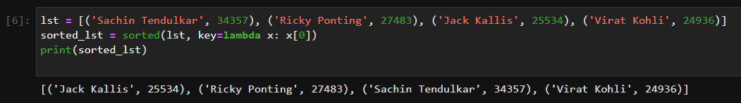

Q2: Write a Python Program to find the squares of all the numbers in the given list of integers using

lambda and map functions.

[1, 2, 3, 4, 5, 6, 7, 8, 9, 10]

ANS: 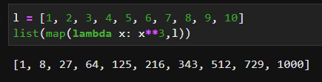

Q3: Write a python program to convert the given list of integers into a tuple of strings. Use map and

lambda functions

Given String: [1, 2, 3, 4, 5, 6, 7, 8, 9, 10]

Expected output: ('1', '2', '3', '4', '5', '6', '7', '8', '9', '10')

ANS: 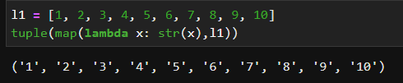

Q4: Write a python program using reduce function to compute the product of a list containing numbers

from 1 to 25.

ANS: 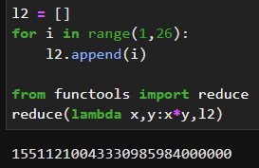

Q5: Write a python program to filter the numbers in a given list that are divisible by 2 and 3 using the

filter function.

[2, 3, 6, 9, 27, 60, 90, 120, 55, 46]

ANS:

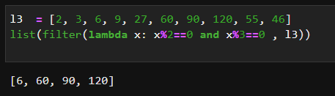

Q6 : Write a python program to find palindromes in the given list of strings using lambda and filter

function.

['python', 'php', 'aba', 'radar', 'level']

ANS: 